Data Loading and Initial Integration
All available samples from the ncRNA detection dataset were provided in three separate files: two Excel workbooks (part1.xlsx and part3.xlsx) and one text file (part2.txt). After loading and concatenation, the resulting feature matrix contained 488,565 samples and 8 numerical features per sample. The corresponding class labels $y ∈\{-1,1$} represented negative (non-ncRNA) and positive (ncRNA) examples, respectively. At this stage, the class distribution was:
Class −1: 325,710 samples
Class +1: 162,855 samples

Handling Missing and Corrupted Samples
Before model training, the dataset was inspected for missing or corrupted entries. A row was considered corrupted if at least one of the eight feature values was missing (NaN) or otherwise invalid.
A total of 669 rows were identified as corrupted. After discarding these samples, the updated class distribution was:
Class −1: 325,059 samples
Class +1: 162,837 samples
Thus, the cleaned dataset contained 487,896 valid samples with complete feature information.

Removal of Duplicate Samples
To ensure that the models were trained and evaluated on unique observations, the dataset was further examined for exact duplicates. Duplicate samples were defined as rows with identical values across all eight features and the corresponding class label; 133,558 duplicate rows were identified. After duplicate removal, the final working dataset consisted of 354,338 unique samples, with the following class distribution:
Class −1: 210,057 samples
Class +1: 144,281 samples

This deduplicated and fully observed dataset was then used as the input for subsequent preprocessing steps and for training the SVM-BM, classical SVM, and AdaBoost models.

Exploratory Analysis of Feature Distributions
To better understand the structure of the dataset and evaluate the separability between ncRNA and negative samples, several exploratory visualizations were generated. As shown in Fig. 1, the dataset exhibits a moderate class imbalance, with class -1 containing 210,057 samples and class +1 containing 144,281 samples. Although the imbalance is not extreme, it highlights the importance of using resampling strategies such as SVM-BM, which are designed to mitigate the bias introduced during classifier training [REF SVM].

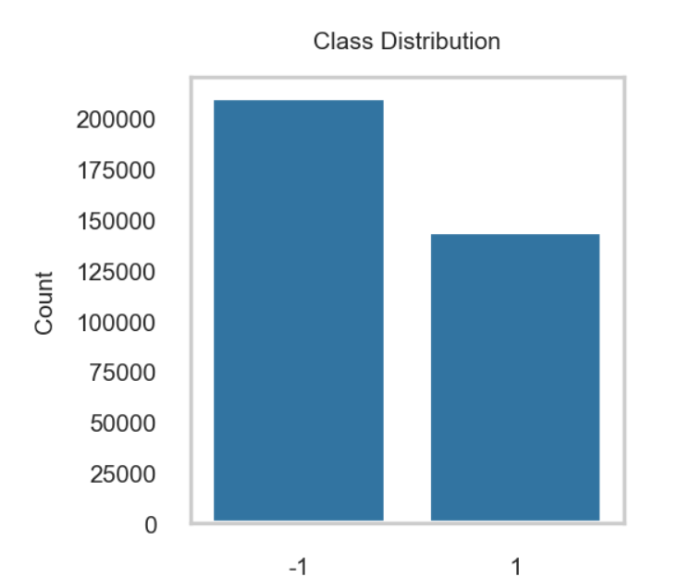

Figure 1. Class distribution of the cleaned dataset after removing corrupted and duplicate rows

To assess the relevance of individual features for classification, Pearson correlation coefficients were computed between each of the eight input features and the binary class labels. The resulting correlations are presented in Fig. 2. Features 1 and 2 show the strongest associations with the class label, with Feature 1 exhibiting a moderately negative correlation (approximately -0.35) and Feature 2 showing a weaker negative correlation (around -0.12). These two features correspond to the folding free energy change and the length of the shorter RNA sequence, respectively; both biologically meaningful indicators expected to differ between real ncRNA pairs and artificially generated negative samples.
In contrast, nucleotide frequency features (Features 3–8) display near-zero correlations, suggesting that they do not individually provide strong linear discrimination. However, they may still contribute to SVM-based models.
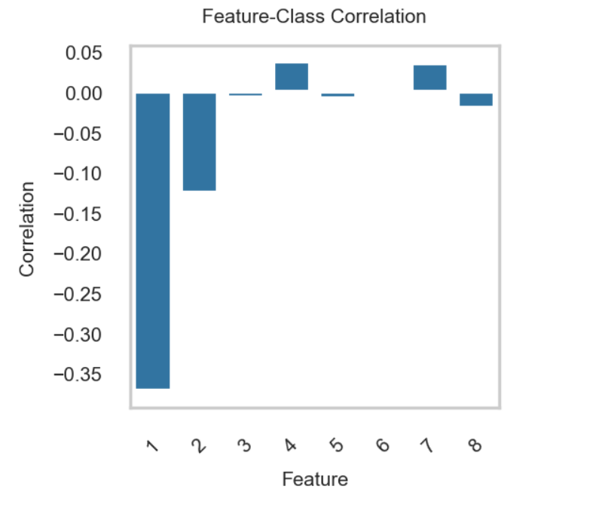

Figure 2. Pearson correlations between each feature and the binary class label

To visualize the joint behavior of the most informative features, a scatter plot was generated for Feature 1 (folding free energy change) versus Feature 2 (shorter-sequence length), as shown in Fig. 3. Each point represents an RNA pair, with colors indicating the corresponding class. As visible in the figure, the two classes exhibit partially overlapping

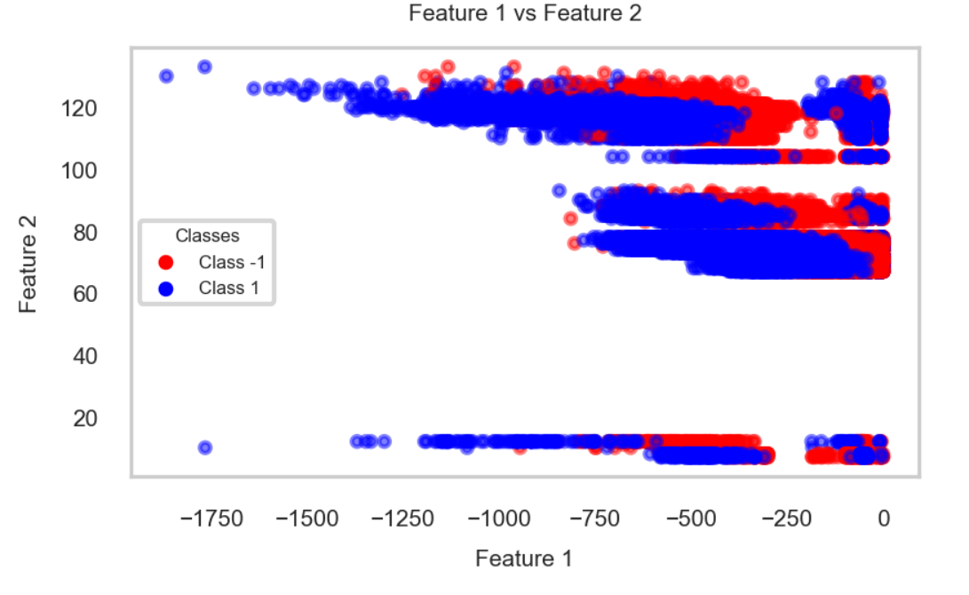

Figure 3. Scatter plot of Feature 1 (folding free energy change) versus Feature 2 (shorter-sequence length) for both classes

Principal Component Analysis (PCA)
To further investigate the structure of the eight-dimensional feature space and evaluate the potential benefits of dimensionality reduction, Principal Component Analysis (PCA) was applied to the normalized feature matrix. PCA was used here as an exploratory tool to assess variance distribution and examine whether any combination of features provides improved class separation.

Explained Variance and Component Selection
The proportion of variance explained by each principal component is shown in Fig. 4. The first three components together account for more than 70% of the total variance, with PC1 alone explaining approximately 32%. The remaining components contribute progressively smaller amounts of variance, with PC7 and PC8 providing minimal additional information.
The cumulative explained variance curve (Fig. 5) confirms that the first six components capture approximately 95% of the variability in the dataset. This indicates that much of the structure of the original eight features can be represented in a lower-dimensional space without substantial loss of information.

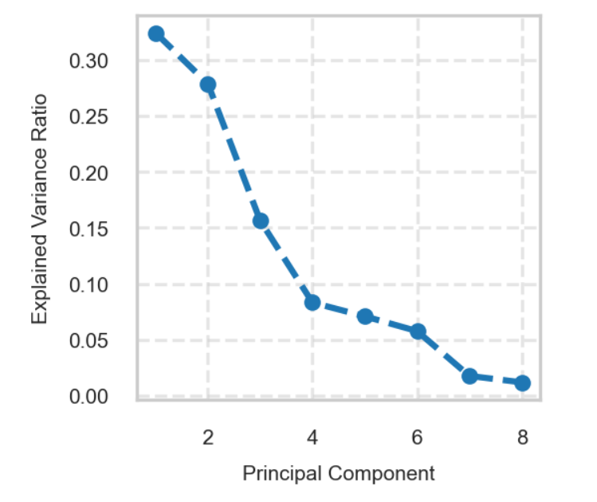
Figure 4. Explained variance ratios of the eight principal components
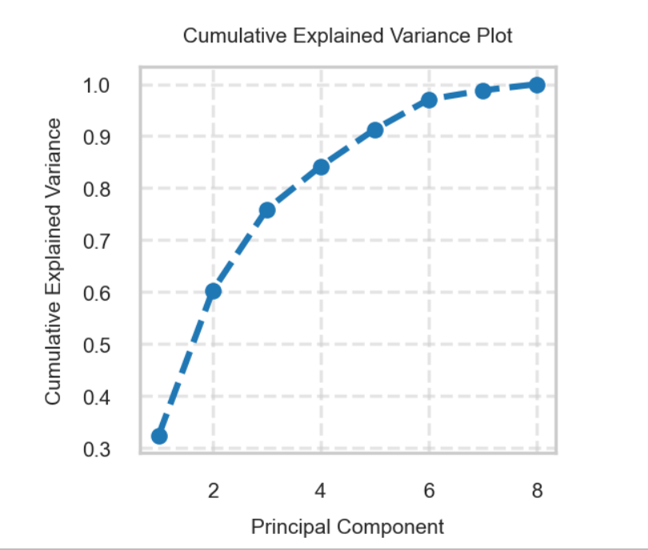
Figure 5. Cumulative explained variance for the PCA components. Approximately 95% of the total variance is retained using the first six components.

To examine whether PCA captures discriminative structure relevant to ncRNA classification, Pearson correlations were computed between each principal component and the binary class labels (Fig. 6).
PC4 and PC6 exhibit the strongest correlations.

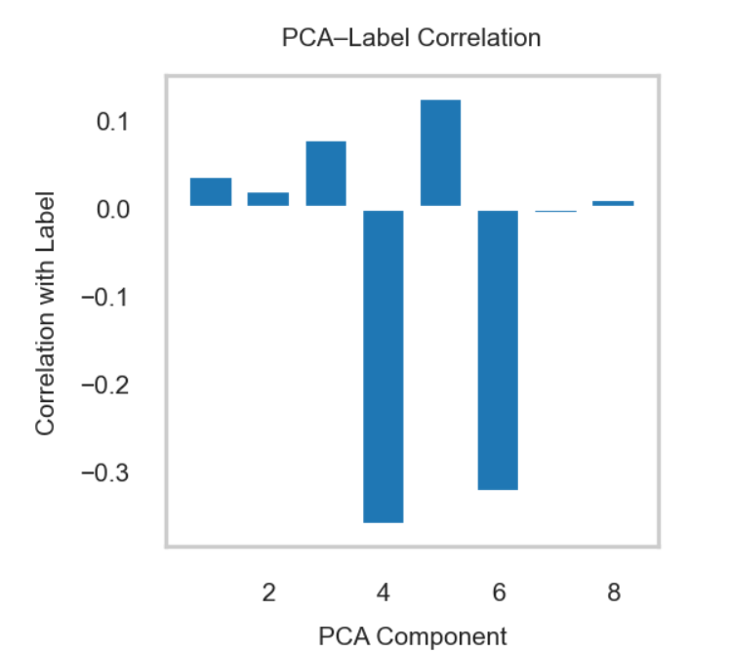

Figure 6. Correlation between each PCA component and the class label. PC4 and PC6 show the strongest associations

Scatter plots of selected principal components were generated to visualize potential class separation in reduced dimensions. Fig. 7 shows the relationship between PC4 and PC6, while Fig. 8 shows PC4 versus PC5. In both plots, samples from the two classes form overlapping, confirming that PCA projects does not produce linearly separable clusters, reinforcing the need for more advanced classification models.

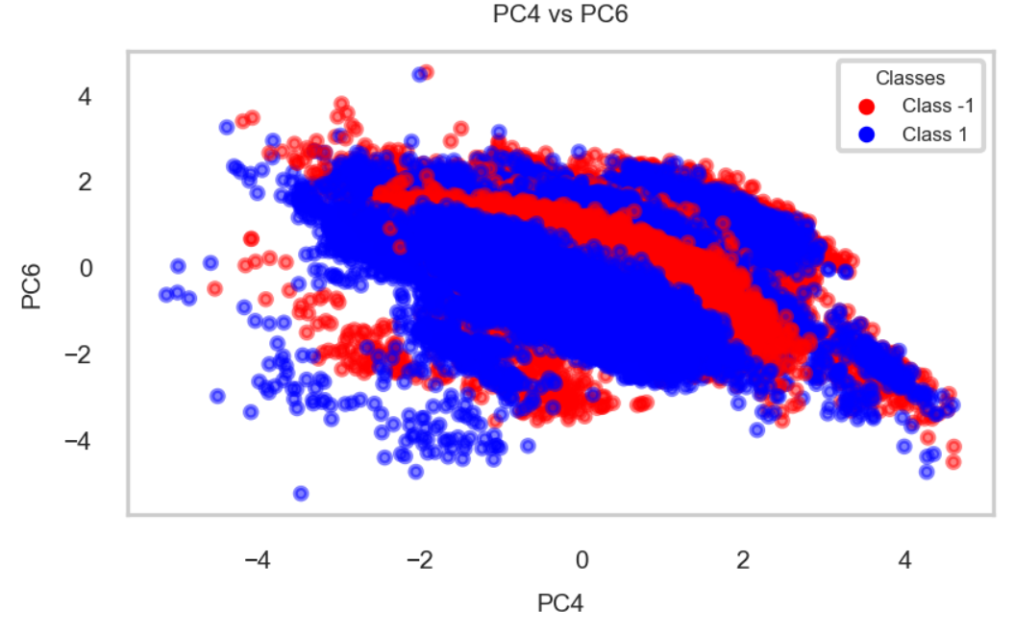

Figure 7. Scatter plot of PC4 vs. PC6. Although overlapping, the two classes exhibit partially distinct cluster shapes.

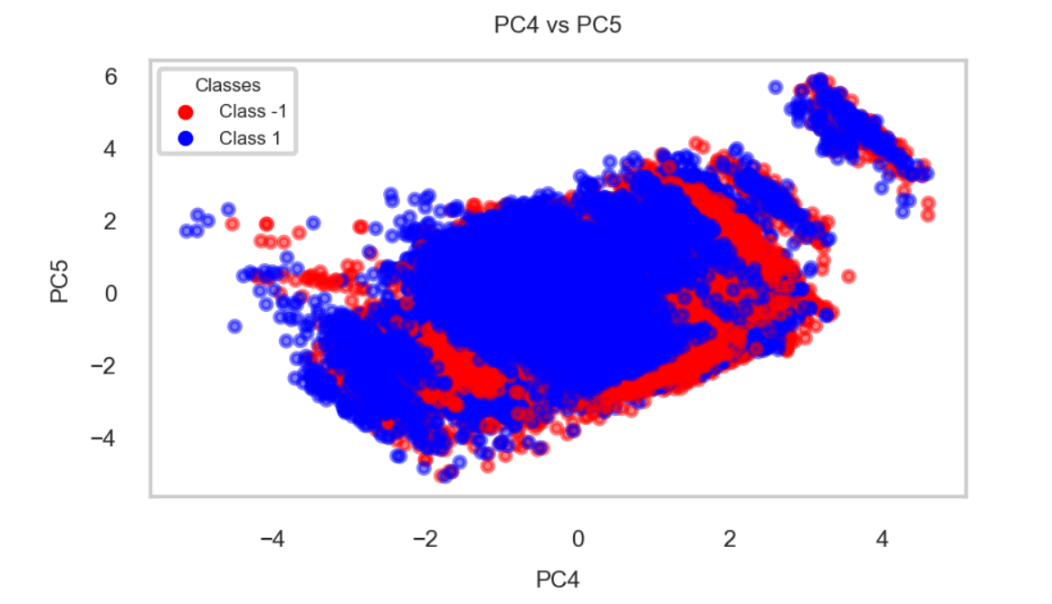

Figure 8. Scatter plot of PC4 vs. PC5. Class-dependent distribution patterns remain visible but nonlinearly separable.

Feature Normalization and Train–Test Split
Before training classification models, all eight original features were standardized using the standard scaler method:
$$X_{\text{norm}}=\frac{X-μ}{σ}$$
This transformation ensures that all features have zero mean and unit variance, preventing any single feature from dominating the optimization process during SVM training.

To objectively evaluate generalization performance, the normalized dataset was randomly partitioned into a 70% training set and 30% test set, with shuffling enabled and a fixed random seed for reproducibility. The resulting dataset sizes includes 248,036 samples for training and 106,302 samples for testing. The probability density of Feature 1 (normalized folding free energy change) was examined separately for the training and testing subsets. Figure 9 displays kernel density estimates (KDEs) and histograms for both classes across the two datasets. The distributions in both the training and testing sets exhibit similar shapes and multimodal patterns. Class −1 samples (blue) tend to concentrate around slightly lower energy values, while class +1 samples (red) show heavier density around higher normalized feature values.

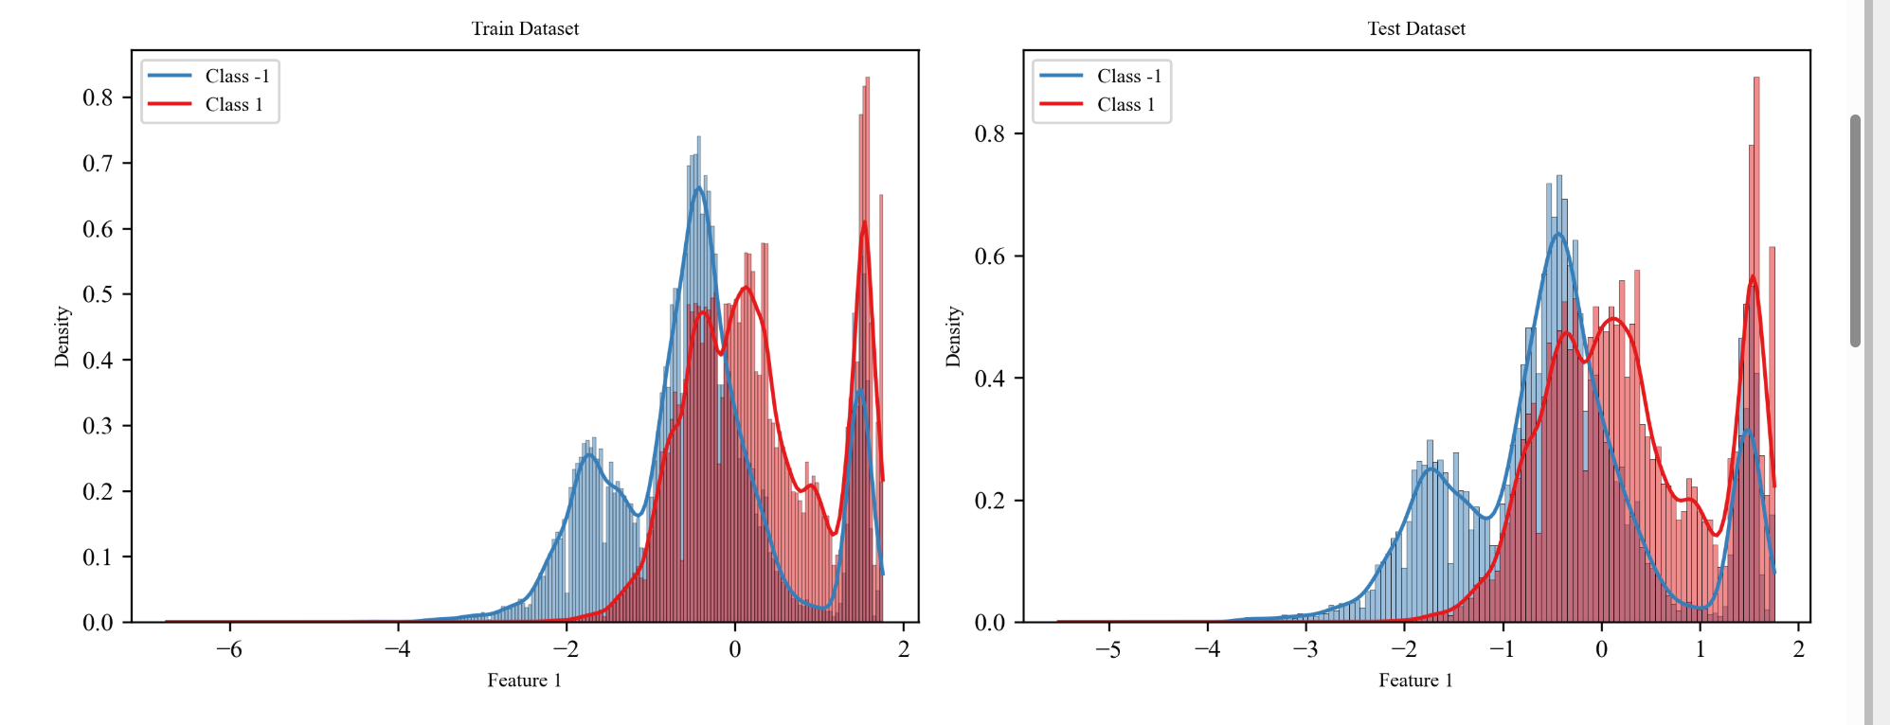
Figure 9. Density and histogram plots of Feature 1 for both classes in the training (left) and testing (right) datasets

SVM-BM

SVM-BM (Support Vector Machine - Boosted Markov chain) is a boosting-style ensemble method designed to improve the performance of linear SVM classifiers by repeatedly training them on carefully selected subsets of the data. Unlike standard boosting, which reweights samples deterministically using exponential weights, SVM-BM uses a Markov chain Monte Carlo (MCMC) mechanism to stochastically explore informative subsets of the training data. The goal is to force each SVM in the ensemble to focus on difficult, borderline, or misclassified samples.

At the core of SVM-BM is the idea of treating an entire training subset $D_{t}=\{z_{i}\}_{i=1}^{N}​$(each containing N samples) as a state in a Markov chain. Rather than modifying sample weights, SVM-BM repeatedly constructs new subsets by replacing one element at a time through probabilistic acceptance rules. The chain evolves from $D_{0}$​ to $D_{1},D_{2},…,$ and each $D_{t}$​ is used to train an SVM classifier $g_{t}$​. Because each iteration introduces targeted sampling of informative data points, the ensemble acquires variety in decision boundaries, which is a key ingredient for effective boosting.

Acceptance Mechanism
For each sample position $i$ in the temporary dataset $D_{t}$​, a candidate training point $z_{*}​$ is drawn uniformly from the full dataset. The algorithm then computes the SVM hinge loss of the previous classifier $g_{t-1}$​ on both the candidate sample and the current sample at that position. The acceptance probability is:
$$p=\min\left\{1,\frac{e^{-l\left(g_{t-1},z_{*}\right)}}{e^{-l\left(g_{t-1},z_{i}\right)}}\right\},$$
which closely resembles a Metropolis–Hastings ratio. This ratio means that candidate samples producing higher SVM hinge loss (i.e., misclassified or near-margin points) are more likely to replace the current entry. As a result, the Markov chain naturally drifts toward subsets containing difficult samples.

Diversity Enforcement
To avoid getting stuck in regions of the sample space, SVM-BM uses a counter​ measuring how many candidate samples have been rejected. Once the number of rejections exceeds a threshold​, the acceptance probability is scaled by a factor $q<1$, making acceptance more likely and ensuring that the algorithm does not lock onto a narrow set of samples.

Training and Boosting Layer
Once a new subset $D_{t}$​ of size $N$ has been constructed, a linear SVM is trained on it to obtain classifier $g_{t}$​. The empirical classification error​ $e_{t}$ is then evaluated on the entire training dataset. the ensemble weight of this classifier is:
$$α_{t}=\frac{1}{2}\log\left(\frac{1-e_{t}}{e_{t}}\right)$$
Only classifiers with positive $α_{t}$​ are kept, ensuring that each SVM contributes to the final ensemble only if it performs better than random guessing. The final decision function is:
$$f\left(x\right)=\text{sign}\left(\sum_{t=1}^{T}{α_{t}g_{t}\left(x\right)}\right)$$
which is a weighted majority vote over all accepted SVMs.

Baseline Ensemble Models

In addition to the proposed SVM-BM algorithms, two additional baseline ensemble approaches were implemented for comparison: (1) AdaBoost with SVM learners, and (2) a random-subsample SVM ensemble. These methods were selected to ensure that all models rely on comparable training subsets of size N per learner, enabling a fair evaluation of how Markov resampling influences performance relative to classical sampling strategies.

AdaBoost with SVM Learners
A customized AdaBoost procedure was implemented in which each weak learner is a linear SVM trained on a weighted bootstrap sample of N points drawn from the training set. This design matches the structure of SVM-BM, where each weak model also operates on a subset of size N.
At each boosting round, a probability distribution​ $w_{t}$over the training samples is maintained. A bootstrap sample of $N$ instances is drawn according to $w_{t}$​, and a linear SVM is trained on this subset. The trained classifier then predicts the labels of all training samples, and the weighted classification error is computed.
$$ε{}_{t}​=\sum_{i:{y_{i}}_{}=h_{t}​\left(x_{i}​\right)}{w_{t,i}}$$
The corresponding learner weight is scaled according to the standard AdaBoost formula:
$$α_{t}=\frac{1}{2}\ln\left(\frac{1-ε_{t}}{ε_{t}}\right)$$
The sample weights are then updated multiplicatively followed by normalization.
$$w_{t+1,i}=w_{t,i}\exp\left(-α_{t}y_{i}g_{t}\left(x_{i}\right)\right)$$
This encourages future weak learners to focus on instances that were misclassified in previous rounds. After T rounds, final predictions are produced by a weighted voting rule:
$$H\left(x\right)=sign\left(\sum_{t=1}^{T}{α_{t}g_{t}\left(x\right)}\right)$$

Random-Subset SVM Ensemble (Bagged SVMs)
As another baseline, a simple subset-based SVM ensemble was implemented. Instead of using weighted sampling or Markov transitions, this method trains T independent SVMs, each on a random, unweighted subset of N samples drawn uniformly from the training data.
For each ensemble member, a subset is selected by uniform random sampling without replacement and a linear SVM is trained on this subset.
$$D_{t}=\{\left(x_{i},y_{i}\right):i∈S_{t}\}$$
Prediction is performed using majority voting over the T SVMs:
$$H\left(x\right)=sign\left(\sum_{t=1}^{T}{g_{t}\left(x\right)}\right)$$

Unlike AdaBoost, this ensemble does not adapt weights or emphasize difficult samples. It serves as a baseline representing a classical bagging-style approach using SVMs trained on small subsamples.

4. Results

To evaluate the performance of the SVM-BM algorithm under severe subsampling constraints, all ensemble models were trained using subsets of only N=10 samples per iteration and a total of T=10 rounds. This design intentionally stresses the learners by providing an extremely limited amount of information at each step. The results obtained on the held-out test set demonstrate clear differences in how each method copes with the challenge of tiny-sample weak learners. The confusion matrixes of each methods were shown in fig 1

The SVM-BM model exhibited the strongest resilience to extreme subsampling. Across the ten iterations, the weak learners achieved training accuracies generally between 0.67 and 0.79. The full SVM-BM model reached a test accuracy of 0.8029, accompanied by an F1-score of 0.7683 and a ROC-AUC of 0.8318. Its confusion matrix shows that the method correctly identified a large majority of positive and negative samples, achieving a balanced error profile. Also, the Markov subset refinement step required only 13–25 candidate subset evaluations per iteration. Total training time was approximately 3.90 seconds.

AdaBoost with SVM weak learners performed moderately well under the same conditions, though its sensitivity to weighted resampling was evident in the fluctuating weighted errors and inconsistent boosting coefficients. Some iterations yielded nearly random or slightly inverted classifiers, as shown by negative or near-zero $αtα_{t}αt$​ values. Nevertheless, the final ensemble achieved a test accuracy of 0.7561, an F1-score of 0.6711, and a ROC-AUC of 0.8536, indicating reasonable discrimination capability despite weaker precision–recall balance. Its confusion matrix reveals a substantial number of false negatives.

Method | Sampling Strategy | Weak Learner | Test Accuracy | F1-score | ROC-AUC | Confusion Matrix | Training time (seconds)
SVM-BM | Markov-chain subset optimization | Linear SVM | 0.8029 | 0.7683 | 0.8317 |  | 3.8959
   | Predicted -1 | Predicted +1
  Actual -1 | 50625 | 12447
  Actual +1 | 8500 | 34730
AdaBoost | Weighted bootstrap | Linear SVM | 0.7561 | 0.6711 | 0.8535 |  | 2.9377
   | Predicted -1 | Predicted +1
  Actual -1 | 53936 | 9136
  Actual +1 | 16787 | 26443
Random-Subset SVM Ensemble | Uniform random sampling | Linear SVM | 0.7122 | 0.5089 | 0.8223 |  | 0.0164
   | Predicted -1 | Predicted +1
  Actual -1 | 59867 | 3205
  Actual +1 | 27380 | 15850

conclusion

This study evaluated the SVM-BM algorithm, a boosting framework that integrates Support Vector Machines with a Markov-based resampling mechanism designed to construct informative training subsets under severe sample-size constraints. Using only N=10 samples per iteration, the method demonstrated strong resilience to extreme undersampling by consistently locating high-quality subsets that allowed each weak learner to maintain meaningful discriminative power. Across all experiments, SVM-BM achieved the most balanced and robust predictive performance, surpassing both classical AdaBoost with SVM weak learners and a random-subset SVM ensemble.
The comparative analysis showed that while AdaBoost can maintain reasonable ranking performance (as reflected by its ROC-AUC), it suffers from instability when the number of available training samples per iteration becomes very small, often producing weak learners with near-random or inverted decision boundaries. The random-subset ensemble, although computationally trivial, proved inadequate for capturing the underlying structure of the ncRNA classification problem under such restrictive subset sizes. In contrast, the Markov resampling mechanism of SVM-BM effectively explored the subset space and consistently selected sample combinations that enhanced the predictive strength of the ensemble. Overall, the results demonstrate that the SVM-BM methodology offers a powerful and efficient alternative for classification tasks where only small, strategically chosen subsets of data can be used during training. This makes the approach especially relevant for domains involving high computational cost per weak learner or limited labeled data.

Code Availability
All code developed for this study, including the complete implementation of the SVM-BM algorithm, the AdaBoost and random-subset SVM baselines, and all preprocessing, visualization, and evaluation scripts, has been made publicly available through GitHub Repository.

